Year 11 Chemistry
AECHE

Unit 1

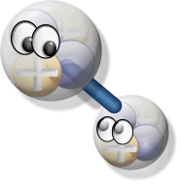

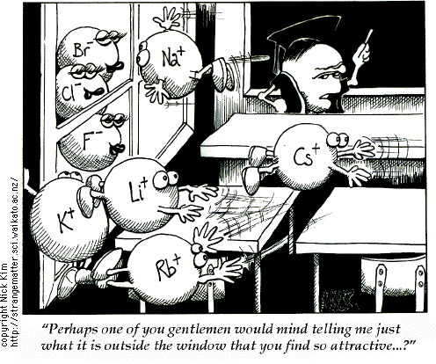

INTERMOLECULAR FORCES

Review of electron dot diagrams

- Draw electron dot diagrams for the following molecules and identify any single covalent bonds, double covalent bonds and coordinate covalent bonds.
a. O₂ b. SO₂

c. SO₃ d. CO

- Use electron dot diagrams and straight line bond formulas to represent the following:
a. NO₃⁻ b. PO₄⁻³

c. NaClO d. Ca(OH)₂

- Octet rule does have limitations and does not always apply. Some important exceptions to the octet rule are:

Be and B being small atoms form molecules with only 2 and 3 electrons pairs respectively - BeCl₂, BF₃. Draw electrons dot diagrams for:

BeCl₂ BF₃

The valence shell electron pair repulsion theory (VSEPRT) and Lewis structure diagrams can be used to explain, predict and draw the shapes of molecules.
Molecular Shape

- Shapes of simple molecules include linear, triangular planar, tetrahedral, pyramidal and bent (or V shaped).

- Molecule shape is depicted by the Valence Shell Electron Pair Repulsion theory or VSEPR.

- It assumes that the shape of a molecule is caused by mutual repulsion (like charges) of the valence electrons (both bonding and non bonding) of the central atom in a molecule.

- The central atom is the atom to which all other atoms attach.

- Thus, valence shell groups try to achieve maximum angular separation while still remaining in the valence level of the central atom in a molecule.

- The electron pairs in the valence electron level of an atom are arranged as far apart as possible to minimise repulsion.

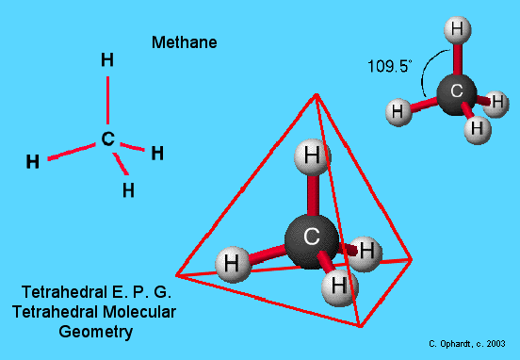

- The number of electron pairs around the central atom can be determined by drawing the Lewis structure for the molecule.
- The geometry of the molecule depends on the number of bonding groups (pairs of electrons) and the number of nonbonding electrons (lone pairs) on the central atom.

- When counting groups of valence electrons use the following rules:

each single covalent bond = 1 group of electrons.
each double covalent bond = 1 group of electrons.
each triple covalent bond = 1 group of electrons.
each coordinate covalent bond = 1 group of electrons.
each lone pair of electrons = 1 group of electrons.

Shape of the molecule determined from the number of groups of electrons as follows

Central atom other attached atoms ______ covalent bond lone pair


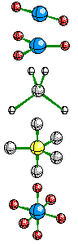
1 or 2 groups of electrons = linear shape
e.g. H₂, HCl, BeF₂

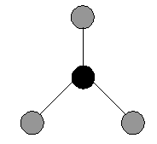

3 groups of electrons and = triangular planar shape
none of these are lone pairs
e.g. BF₃, SO₃, NO₃⁻

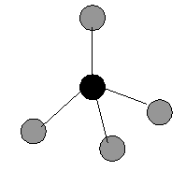


4 groups of electrons and = tetrahedral shape
none of these are lone pairs
e.g. CH₄, CF₄, CCl₄

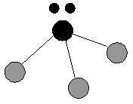

4 groups of electrons and
one of these is a lone pairs = pyramidal shape
e.g. NH₃, PCl₃

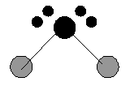
4 groups of electrons and
two of these are lone pairs = bent or V shape
e.g. H₂O, F₂O


4 groups of electrons and
three are lone pairs = linear
e.g. Cl₂

- The ideal bond angles allow the greatest equal angular separation of all electron groups. This assumes that all groups of electrons repel equally.

- As repulsion between lone pairs of electrons is greater than other electron groups, the actual bond angles may vary from ideal conditions.

- If lone pairs of electrons are present on the central atom then actual bond angles will be reduced as shown in the table below.

E.g. water – expect bond angles to be 109.5° due to tetrahedral shape but lone pair causes greater repulsion and greater angle, forcing bonding pairs closer to 104.4°

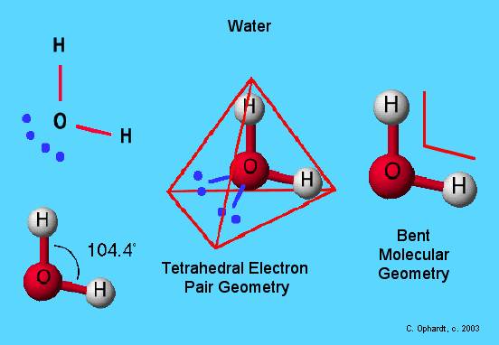

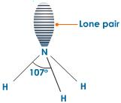
E.g. ammonia – nitrogen has one lone pair which
influences bonding pairs between N and H causing
an angle of 107°. Ammonia has a pyramidal shape.

• Diatomic and some triatomic molecules are linear (180°).

Predicting Molecular Shape Using the Principles of VSEPR
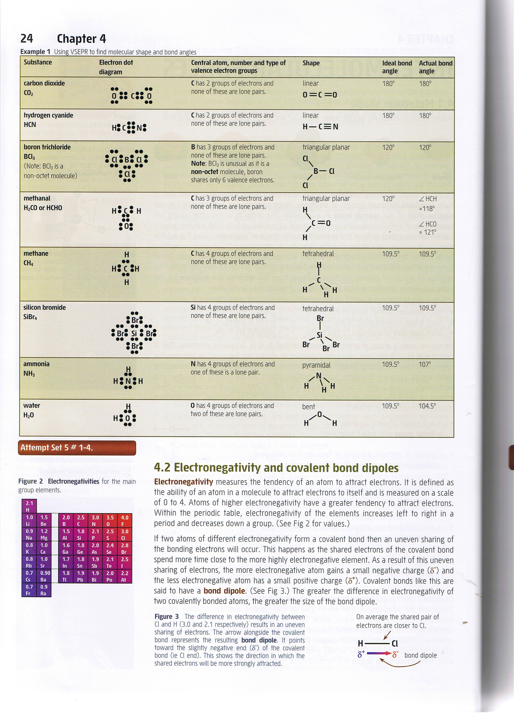
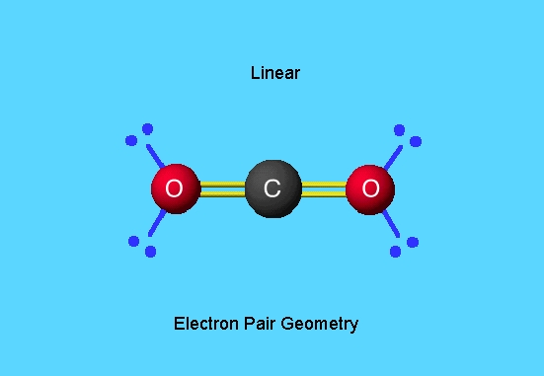

Problem Set
1. Draw and name the shape of the following covalent molecules. Show any non-bonding pairs of electrons that cause the shape.
a. HCl b. BeCl₂

c. BCl₃ d. CCl₄

e. NCl₃ f. H₂S

g. SiH₄ h. CH₃Cl

2. Predict and draw the shapes of the following molecules and ions.

a. SF₂ b. BCl₄⁻

c. Cl₂O d. ClO₃⁻

e. CO₃⁻² f. SO₃⁻²

The polarity of molecules can be explained and predicted using knowledge of molecular shape, understanding of symmetry, and comparison of the electronegativity of atoms involved in the bond formation.
ELECTRONEGATIVITY and BOND POLARITY

Electronegativity
• Measures the tendency (0 to 4) for the atoms of an element to attract electrons.
• Atoms of higher electronegativity have a greater tendency to attract electrons.
• Periodic table
• Electronegativity increases from left to right in a period (due to an increase in nuclear charge) and
• Decreases down a group (size of the atoms increases and attractive force of the shielded nucleus is diminished).
• Electronegativities are greater for non-metals - inert gases are not considered electronegative.
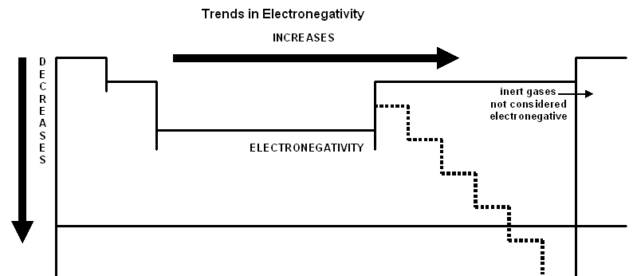

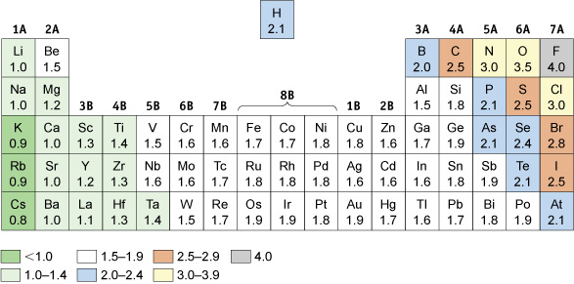

Polarity of Bonds

- When a bond forms between two different atoms, an unequal sharing of electrons occurs - the atoms have different electron attracting abilities (electronegativity) and hence a polar bond results.

- Nature of the bond depends on the differences of the electronegativities of the atoms.
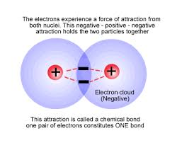
- Bonds may be:
  - purely covalent - forms between two identical atoms; electrons are shared equally.

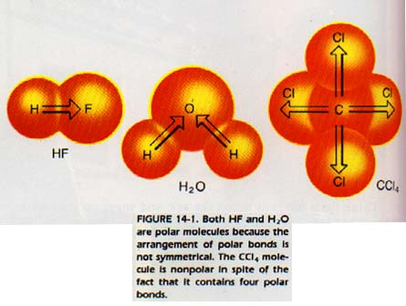
  - polar covalent - two different atoms; the electrons are not shared equally; the electron pair spends more time near the nucleus of the more electronegative atom which will acquire a partial negative charge.

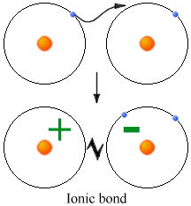
  - or ionic - atoms which vary greatly in terms of electronegativity; the electrons are completely transferred from the metallic element to the more electronegative atom (the non-metal atom).

- Covalent bonds between atoms of differing electronegativity have a bond dipole (electric dipole) and are called POLAR BONDS.

- A bond dipole means the more electronegative atom has a small negative charge, δ-, and the less negative atom has a small positive charge, δ+.
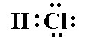
H Cl electric dipole
i.e. δ+ δ-

Electronegativity 2.2 3.2

Example – bonds with fluorine from elements in row 2

Molecule | Diff in E.N. | Result | Bond
F–F | 0 | Equal sharing | Non-polar
O–F in F₂O | 0.52 | F more E.N. | Polar bond
N-F in NF₃ | 0.92 | F more E.N. | Polar bond
C-F in CF₄ | 1.41 | Large difference | Strong polar bond
B-F in BF₃ | 1.92 | Large difference | Very polar bond
Be-F in BeF₂ | 2.39 | Very large difference | Very polar bond
Li-F | 3.0 | Charge separation | Ionic bond

BeF₂ would be expected to form an ionic compound but it is covalent. Find out why.

Polarity of Molecules – Molecular dipoles

- A dipole is a charge separation created in a polar bond due to unequal sharing of electrons.

- A dipole is represented as → with the arrow head towards the negative end of the dipole.
- A net dipole in one direction is formed only when the molecule is not symmetrical.
- A molecular net dipole is the vector sum of all the bond dipoles within a molecule. E.g. water and ammonia.

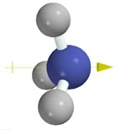

N
H H
H

Vector addition net dipole

- Molecules possessing a net dipole are said to be polar while with a zero net dipole are non polar.

- Polarity of a molecule is predicted by drawing its molecular shape and indicating all of its bond dipoles.

- If these cancel out (due to opposing direction) then the molecule is non polar. If not, the molecule is polar.
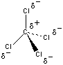

No net dipole

- Non symmetrical molecules with polar bonds will have a net molecular dipole.

In symmetrical molecules the net dipole is zero.

- What is the difference between the terms polar molecule and polar bond or are they the same thing?

- Can a molecule be non-polar and yet have polar bonds? Explain with example.

Individual Bond Dipoles and Net Molecular Dipole

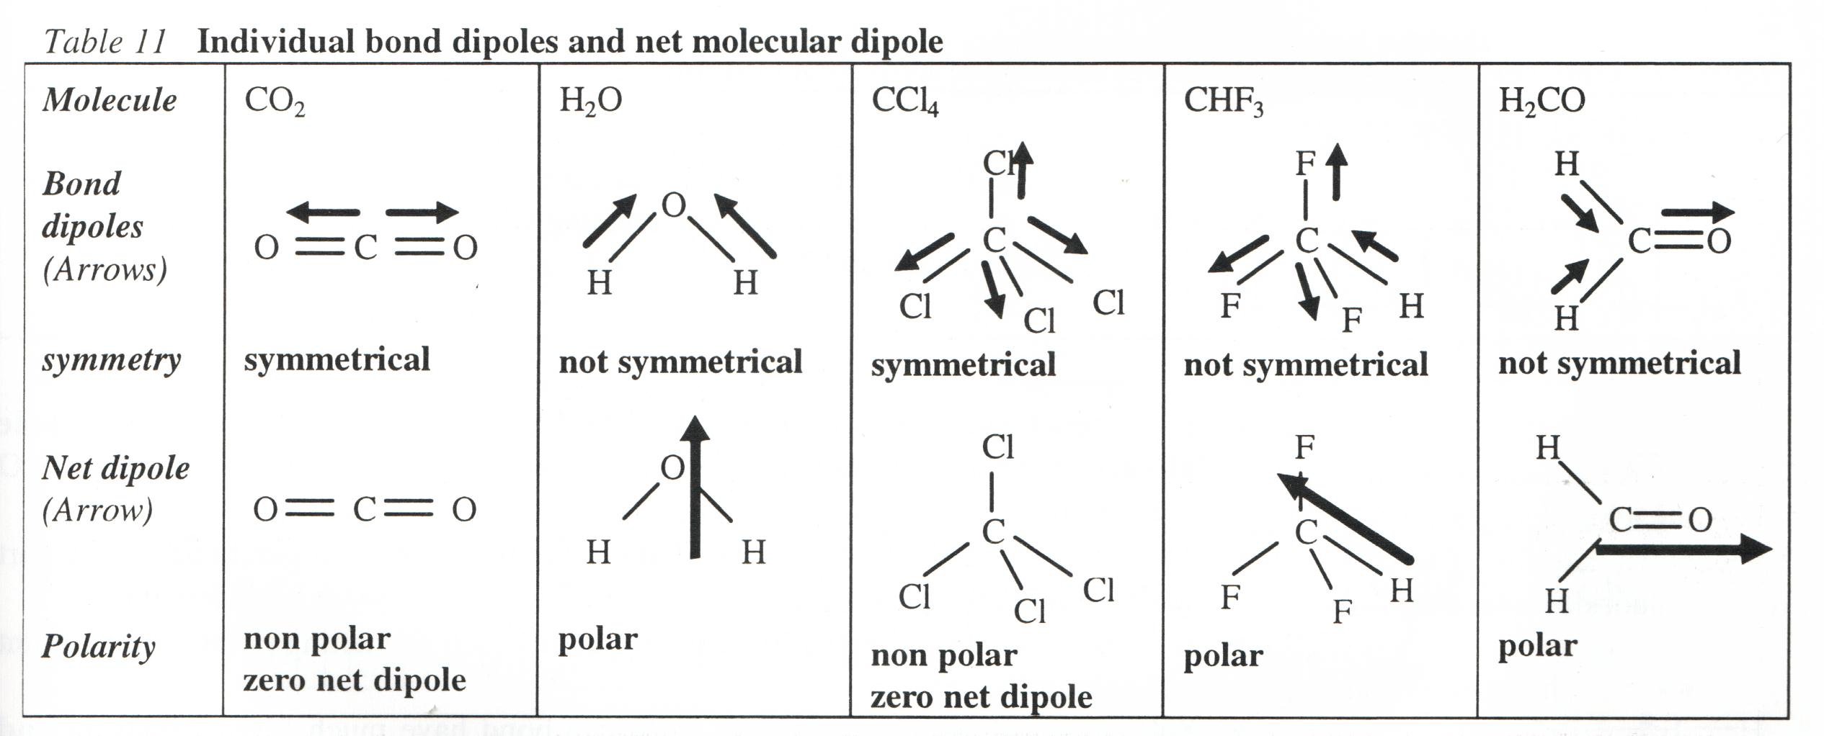

- To determine which molecules have a net charge separation we need to consider the presence of polar bonds and the shape of the molecule.

1. | HI | linear | - I more E.N. than H  - I attracts shared e⁻s  - I –ve, H +ve  - strong dipole | δ+ δ-  =
2. | BF₂ | linear | - strong bond dipoles  - no molecular dipole | δ- δ+ δ-  = 0
3. | NF₃ | pyramidal | - strong bond dipoles  - strong molecular  dipole | δ+  δ- δ- =  δ-
4. | CF₃Cl | tetrahedral | - strong bond dipoles  - strong molecular  dipoles | δ- smaller  A dipole  δ+  δ- δ- =  δ-
5. | H₂O | bent | - strong bond dipole  - strong molecular  dipole | δ-  δ+ δ+ =
6. | CF₄ | tetrahedral | - strong bond dipoles  - no molecular dipole | δ-A  A  δ+  δ- δ- = 0  δ-

Polar or non-polar?

Complete the table.

 | H₂S | Cl₂O | CH₃Cl | CH₂Br₂
Electron dot diagram
Draw the shape + lone pairs
Type shape
Draw individual polar bonds
Net dipole
Polar or non-polar?

Construct the following molecules then complete the table.
CCl₄ BBr₃ CCl₃F H₂S S₈ C₃H₈ C₂H₅OH CF₂I₂

Substance | Sketch shape | Show bond dipoles | Symmetrical? | Show net dipole | Polar molecule?
CCl₄

BBr₃

CCl₃F

H₂S

S₈

C₃H₈

C₂H₅OH

CF₂I₂

Problem Set
1. Which of the following bonds would you expect to be polar?
a. P-Cl in PCl₃ b. O=O in O₂
c. S-O in SO₂ d. N-H in NH₃
e. Sn-Cl in SnCl₄ f. Br-Br in Br₂
g. O-F in OF₂ h. S-H in H₂S

2. Which of the following molecules would you expect to be polar?
a. BeCl₂ b. CF₄
c. Cl₂O d. ClF
e. HBr f. CH₃Cl
g. CCl₂F₂ h. PF₃

3. For each of the following substances state whether you would expect the bonds to be ionic, pure covalent or polar covalent.

a. NaF b. I₂
c. SiBr₄ d. MgI₂
e. PH₃ f. CO₂
g. MgO I h. OF₂

The shape and polarity of molecules can be used to explain and predict the nature and strength of intermolecular forces, including dispersion forces, dipole-dipole forces and hydrogen bonding.

INTERMOLECULAR FORCES - VAN DER WAALS FORCES

- Attractive forces that exist between molecules (intermolecular forces) in covalent molecular substances – these forces are very weak.

- Van der Waals forces must not be confused with the strong forces (intramolecular forces) that exist between atoms and ions e.g. metallic, ionic and covalent bonds

- Three types of van der Waals forces:
  - dispersion forces,
  - dipole-dipole forces, and
  - hydrogen bonding forces.

Dispersion Forces

- Occur in all molecular materials but they are the only force of attraction between:
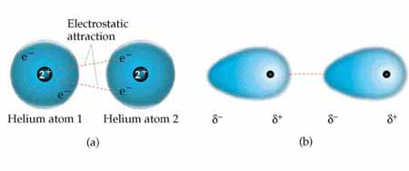
- the noble gases (atoms)
- neutral molecules like halogens and alkanes (non-polar)

- Dispersion forces are the forces of attraction between the electrons of an atom or molecule to the positive nuclei of a neighbouring atom or molecule.
- This net electrical force of attraction is the sum of all the forces of electrical attraction and repulsion (i.e. between nuclei and electron cloud) between neighbouring atoms or molecules.

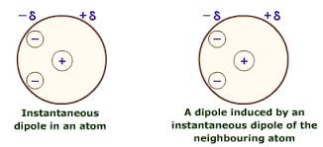
- Due to the random motion of electrons within a molecule, this produces a varying temporary dipole making a molecule temporarily polar.

- A temporary polar molecule causes nearby molecules to develop similar dipoles called induced dipoles.

- Molecules with temporary dipoles or induced dipoles experience weak electrostatic attraction (dispersion forces).
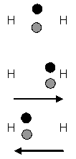
H₂ molecule showing the average position of its two shared electrons. no
dipole is present.

The random movement of electrons produces a constantly changing temporary dipole.

The dipole is indicated with an arrow.

- Temporary dipoles and induced dipoles are in a state of constant rapid change.

- Strength of dispersion forces increases with increasing number of electrons, i.e. molecular size therefore boiling/melting points increases down the group.

- The shape of molecules also effect dispersion forces e.g. isomers of pentane
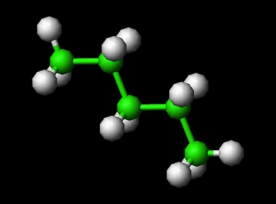
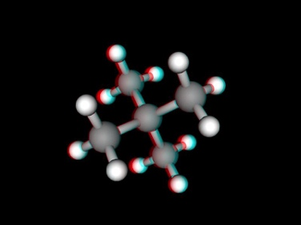

Pentane 2,2- dimethylpropane
Boiling point = 36°C Boiling point = 9.5°C

- Greater surface to surface contact between pentane molecules (linear in preference to branched or spherical shape) produced stronger forces of attraction than in 2,2- dimethylpropane.

- As the size of the molecules increases so does the strength of the dispersion forces due to a greater surface contact between molecules
e.g. ethane has a higher boiling point than methane.
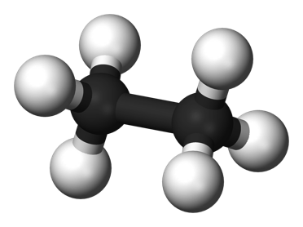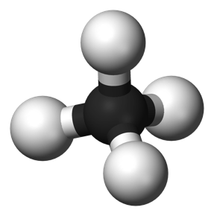
- Stronger dispersion forces result in higher melting and boiling points.

- Substances whose molecules attract by dispersion forces only, will be soluble in each other.

Dipole-Dipole Attraction
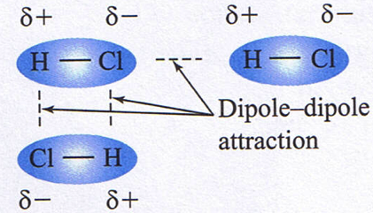
- Polar molecules experience electrostatic attraction between the dipoles in neighbouring molecules - dipole-dipole attraction.
- Molecules have charged ends
- Electron arrangement causes atoms to tend to be +ve or –ve.
- Oppositely charged ends attract.
- Relatively weak forces, but stronger than dispersion forces.
Strength of these forces increases with increasing molecular polarity.
- Melting points tend to be low due to weak forces. Compare HCl (polar covalent –114ºC) with NaCl (ionic 801ºC).
Stronger dipole-dipole forces result in higher MP’s and BP’s.
- Examples include HCl and HBr.

- These forces hold the molecules together and effect many physical properties of the substance.
- The degree of effect depends upon the size of the molecular dipole.

- These physical properties include –
- melting point – increases as dipole gets stronger.
- boiling point – increases as dipole gets stronger.
- viscosity – increases as dipole gets stronger.
- density – increases as dipole gets stronger.
- solubility – polar dissolves polar, non-polar dissolves non-polar
- heat of vapourisation – increases as dipole gets stronger.

- Substances whose molecules attract by dipole-dipole forces (polar substances) will be soluble in each other.

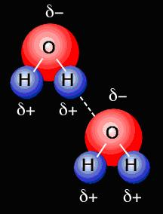
Hydrogen Bond Forces

- Occur when a hydrogen atom is covalently bound to NOF:
(nitrogen, oxygen, fluorine)

- Examples includes NH₃, H₂O, HF, methanol etc.

- Hydrogen bond force is the strongest of the three types of van der Waals forces. These bonds are stronger due to:
- high charge separation
- small size of the H atom; this allows close approach
- attraction between H nucleus (+) and unshared electron pair of N, O or F.
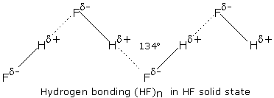

covalent bond

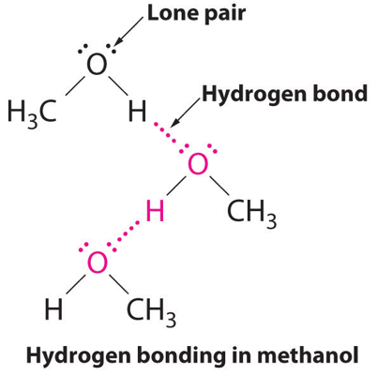
- Hydrogen bond forces are directional.

- A hydrogen bonding force is an attraction between a lone pair of electrons from an N, O or F atom in a polar molecule and a hydrogen atom that is already covalently bonded to another N, O or F atom.

- Only Certain Hydrogen Atoms are Capable of Hydrogen Bond Forces

O H¹ F H²

C C C C N H³

H⁸ O H⁷ H⁶ H⁵ H⁴

In this structure the hydrogen atoms labelled 3, 4 and 8 are capable of hydrogen bond force while those labelled 1, 2, 5, 6 and 7 are not capable of hydrogen bonding.

- Why are 3,4, & 8 capable of hydrogen bond force while those labelled 1,2,5,6 and 7 are not?

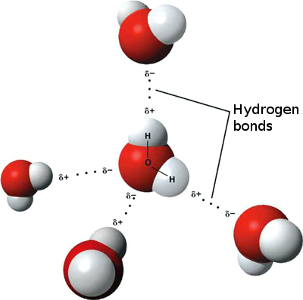
- Sometimes hydrogen bonding forces are described as an extreme form of dipole-dipole attraction where a strongly positive H atom is attracted to a strongly negative F, O or N atom.

- In substances such as HF, NH₃ and H₂O the Boiling Point and Melting Point are elevated due to the hydrogen bonds holding the substance together.

- This is most noticeable in water due to an effective double hydrogen bond force.

- Note: the presence of hydrogen bond forces in ice creates a very open structure which causes the density of ice to be less than that of water.
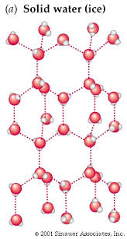

Hydrogen bond forces in ice

- Similarly – alcohols e.g. methanol
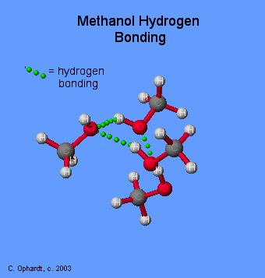

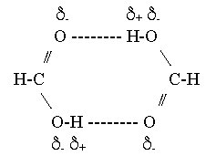
- carboxylic acids e.g. methanoic acid

hydrogen bond force --------

Hydrogen bond force

- INTRA MOLECULAR hydrogen bond forces can also exist e.g. isomers.

Hydrogen bond force

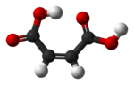
δ+ δ-
O ---
H O
Cis-butenedioic acid

- This isomer has a lower Melting Point than trans butanoic acid as the latter has intermolecular hydrogen bond force.

- Ammonia NH₃ is easily liquefied under pressure.

- Note: hydrogen bond forces affect the physical properties as for dipole-dipole interactions but to a greater extent due to their greater strength.

dispersion < dipole-dipole < hydrogen < covalent
forces forces bond forces bonds

- Place the following in order from lowest BP to highest BP. Next to each, describe the forces of attraction for each molecule.

Ar, O₂, S₈, I₂, HF, CH₄, H₂O, C₁₀H_{22,} H₂S

Hydrides of groups 15, 16 and 17 accounting for anomalous behaviour of NH₃, H₂O and HF

- The following graph and tables of data show information about the boiling points of hydrides and electronegativities of elements present in these hydrides.

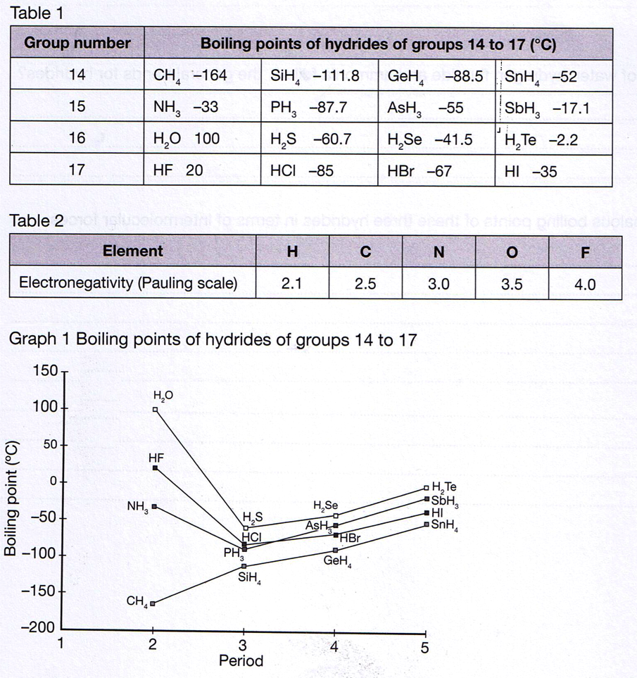
- What is a hydride?

- Most hydrides have low boiling points which increase across the period (most below 0⁰ C)

- However H₂O, HF and NH₃ have significantly higher boiling points.

- Account for the significantly higher boiling point of H₂O, HF and NH₃.

Intermolecular Forces - Points to Note

- Not as strong as ionic, covalent or metallic bonding but are significant attractive forces between all molecules in the solid and liquid states.
Covalent >> Hydrogen >> Dipole-dipole >> Dispersion
Bonding Bond forces forces forces

strongest weakest
- Dispersion forces are present between all particles:
- depend on molecular size and shape.
- they are the only forces between non polar molecules.
- Dipole-dipole forces are usually stronger than dispersion forces and are particularly in small polar molecules.
- Hydrogen bond force is the strongest of the van der Waals forces but is weak compared to covalent bonding.
- It explains the high melting and boiling points of H₂O, NH₃, HF and organic molecules such as alcohols.

Problem Set

1. Which type of intermolecular attraction - dispersion forces, dipole-dipole forces or hydrogen bonding - would be most significant in the following:
NB: most significant intermolecular force is in bold however other forces exist

a. Br₂ _{(l)}

b. NH₃ _{(l)}

c. CH₃CH₂OH _{(l)}

d. I₂ _{(s)}

e. HCN _{(l)}

f. CH₃COOH _{(l)}

g. P₄ _{(s)}

h. CCl₄ _{(l)}

i. CCl₂F₂ _{(l)}

j. CH₂OH
⏐
CH₂OH _{(l)}

2. In each of the following pairs, which substances would you expect to have a higher boiling point? Explain your answer to each one.

a. He or N₂

b. CH₄ or CH₃OH

c. HF or HCl

Observable properties including melting point, boiling point and solubility, can be explained by considering the nature and strength of intermolecular forces for covalent molecular substances.
Melting and Boiling point and Intermolecular forces

- The melting point is the temperature at which attractive forces are overcome to turn a solid into a liquid. The boiling point is the temperature at which attractive forces are overcome to turn a liquid into a gas.
- Melting points and boiling points depend on the strength of forces that exist between the particles that make up a substance.
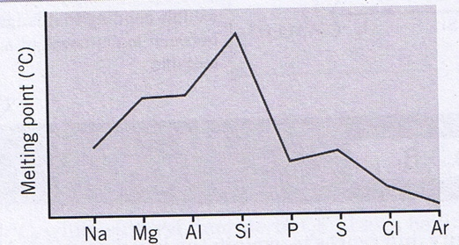
In General:
- Melting points and boiling points show periodic properties. This means that they vary in a regular way or pattern depending on their position in the periodic table.
- The general trend is shown in graph - the stronger the intermolecular forces the higher its melting and boiling points will be.
- They rise to group 14 then decrease to group 18.
- The trend is explained in terms of bonding of the elements.
- Groups 1,2 and 13 elements are metals with increasing valence electrons to increase metallic bond.
- Group 14 elements are covalent network with many bonds so have high melting/boiling points.
- Groups 15 to 18 are covalent molecular or monatomic with only dispersion forces between atoms and molecules so it is much easier to break the forces of attraction.
- Little energy is required to separate the molecules or atoms, hence the low melting points and boiling points.

- Substance that can also interact by dipole-dipole forces will have slightly higher melting and boiling points compared to similar substances of similar molecular size that can’t interact this way.
- The dipole-dipole attraction requires more energy to separate the molecules which leads to higher melting points and boiling points.

- Hydrogen bonding forces also increases the melting and boiling points.
- Since hydrogen bonding forces are usually stronger than dipole-dipole attractions, molecules that can form hydrogen bonding forces usually have higher melting points and boiling points.

Compound | Molecular formula | Molecular mass | Molecular polarity | Boiling point
propane | C₃H₈ | 44 g mol⁻¹ | nil | -42 ⁰C
methoxymethane | CH₃OCH₃ | 46 g mol⁻¹ | low | -25 ⁰C
ethanal | CH₃CHO | 44 g mol⁻¹ | moderate | 21 ⁰ C
ethanol | CH₃CH₂OH | 46 g mol⁻¹ | high | 78 ⁰ C
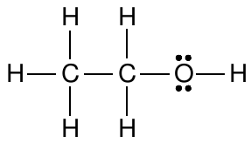
- The four molecules are shown in order.
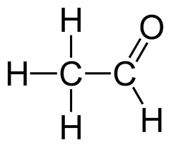
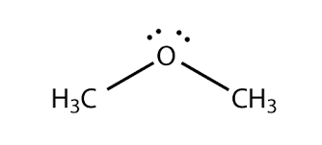
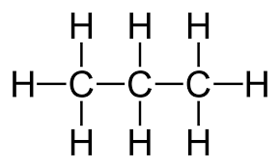

- Account for the different boiling points.

- Interaction between solute and solvent particles in solution

  - What is a solute?

  - What is a solvent?

  - How does a solution form?

4. Explain the rearrangement of “bonds” during the solution process.

Ion-dipole forces
- When ionic compounds dissolve in water bonds are broken and new bonds formed.
- Also, hydrogen bonds between water molecules must be disturbed
- To provide energy for these bond-breaking processes, new bonds must form between separated ions and water molecules in solution.
- The attractive force that exists between ions and polar molecules such as water is called an ion-dipole force.
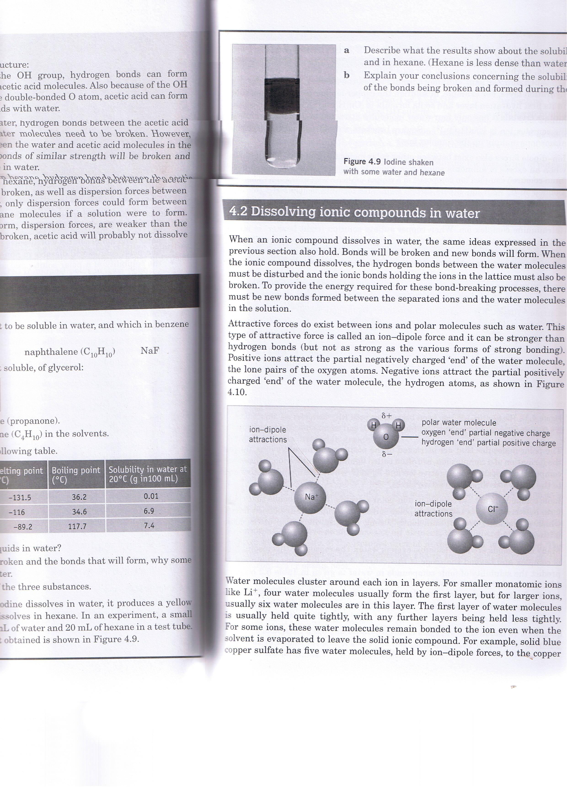
- Positive ions attract partially negatively charged ‘end’ of water molecule (lone pair of electrons on oxygen atom)
- Negative ions attract partially positively charged ‘end’ of water molecule (hydrogen atoms)
- Ion-dipole force is stronger than hydrogen bonding but not as strong as metallic, ionic and covalent bonds.

Polar Solvents:
- bonds between particles in solute are broken and the particles move away to mix with the solvent
  - weaken the force of attraction between oppositely charged ions in crystals
  - break dipole-dipole interactions and ion-dipole interactions respectively
  - break any hydrogen bonds
- bonds between liquid particles are disrupted as solute particles move in between them
- new bonds are formed between the solute particles and the solvent particles
  - solvate molecules and ions by dipole-dipole interactions and ion-dipole interactions respectively
- while water is a polar solvent, it can readily dissolve non-polar substances

Non-polar solvents:
- non-polar solvents dissolve non-polar solutes by forming weak dispersion forces as dipoles are induced.

- Exercise

1. Explain in detail why the following polar substances dissolve in water:

- Methanol (CH₃OH)

- Propanone (acetone)

2. Explain in detail why carbon tetrachloride (CCl₄) does not dissolve in water but does
dissolve in hexane (C₆H₁₄).

